The Lead Engine ⚙️

Introduction: Why Your Backend Matters More Than Your Ads
Welcome to Day 3. So far, we’ve focused on the “front end” of your advertising—the creative, the copy, the targeting. But the truth is, most ad campaigns don’t fail because of bad ads. They fail because of a broken backend.
Imagine your ad is a world-class fisherman, catching the best fish in the sea. Now imagine your backend is a net with giant holes in it. It doesn’t matter how many fish you catch if they all slip away before you can get them in the boat. That’s what happens when you have a weak “Lead Engine.”
This playbook will teach you the high-level mechanics of a powerful Lead Engine. You’ll learn the three critical parts, understand the trade-offs between different lead capture methods, and see why a real system for managing leads is non-negotiable. By the end, you’ll see the invisible infrastructure that turns clicks into customers and how we build it for our high-level clients
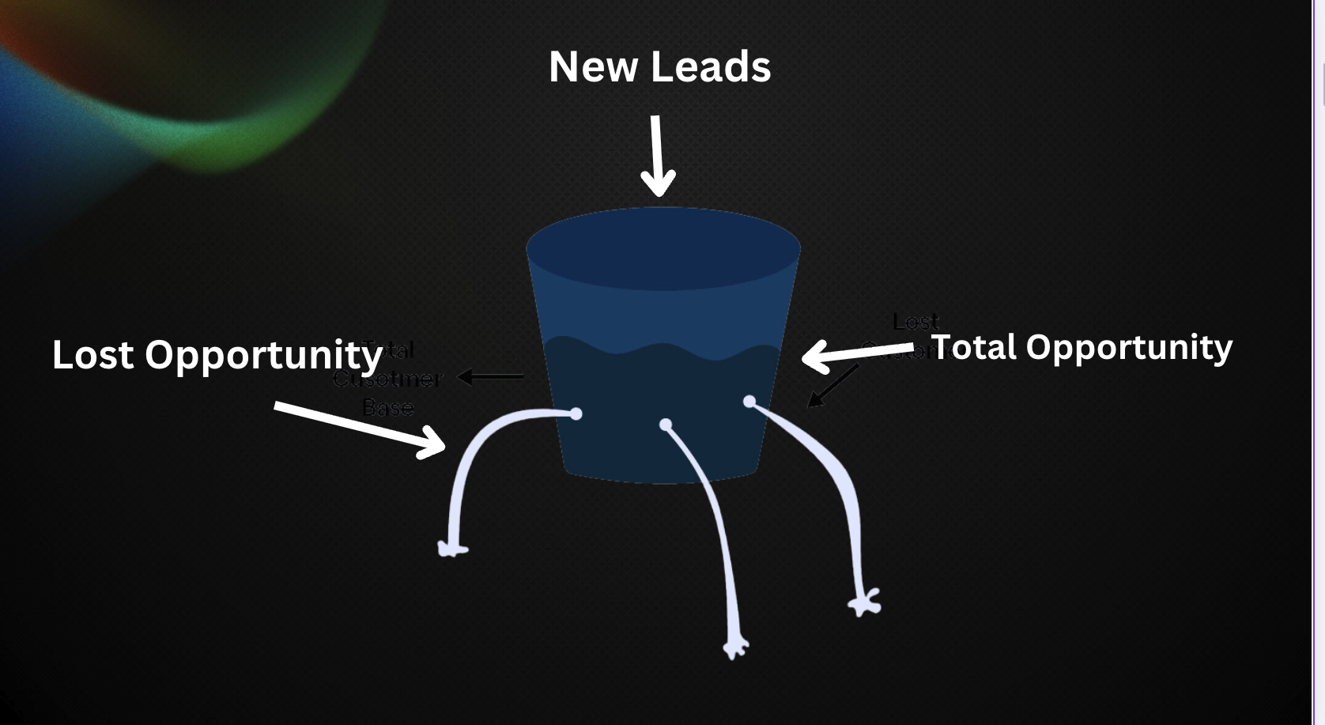

The 3-Part Lead Engine: From Click to Conversation 🔄
At its core, a successful advertising operation isn’t just about running ads. It’s about engineering a seamless process that takes a person from stranger to satisfied client. This process has three distinct, equally important parts

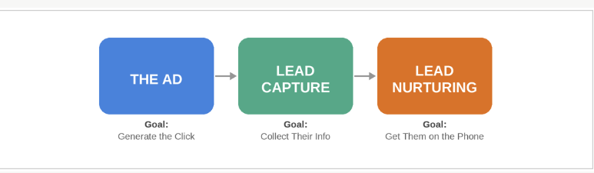

Part 1: The Ad (The Fisherman)
This is what you’ve been learning. The ad’s job is to find the right people and get them to raise their hand. But it’s not just about getting any hand-raise; it’s about getting the right one. We optimize our ads to attract leads who are:
- In-Market & Problem-Aware: They know they have a problem that needs solving now.
- Basically Qualified: They meet the fundamental criteria for your offer (e.g., for a mortgage, they aren’t a 42-year-old borrower looking for a reverse mortgage).
- Responsive: They are genuinely interested and willing to engage in a conversation.
Everything starts here. A well-crafted ad doesn’t just generate a click; it generates a high-quality signal of intent.

Part 2: Lead Capture (The Net)
This is where the hand-off happens. The person has clicked your ad. Now what? You need a reliable, efficient way to collect their information. This is where most beginners drop the ball. Your lead capture method directly impacts both the quantity and quality of your leads. We’ll explore this deeper in the next section.

Part 3: Lead Nurturing (Getting the Fish in the Boat)
This is the final, and most neglected, part of the engine. A new lead is a hot opportunity that decays with every passing minute. The data is terrifying:
Responding to a new lead within the first 5 minutes makes you 21 times more likely to qualify them [1]. After just one hour, the likelihood of making successful contact drops by 10x [2].
Yet, the average business takes 47 hours to respond to a new lead [3]. This is where the money is lost. Lead nurturing is the system of follow-up—automated and manual—that ensures every single lead is given the best possible chance to convert. It’s about speed, persistence, and relevance.
Key Takeaway: Your ad is just the start. The real work begins after the click. A strong Lead Engine ensures that the interest you generate is captured and converted efficiently.

Facebook Lead Forms vs. Your Own Landing Page ⚖️
This is one of the biggest decisions you’ll make in your lead capture strategy. Both have their place, but they serve different goals. Let’s break it down.

Facebook Lead Forms: The Path of Least Resistance
Facebook Lead Forms (or Instant Forms) are native to the platform. A user clicks your ad, and a pre-filled form with their Facebook information pops up. They click “Submit,” and you have a lead.
Pros | Cons
✅ Cheaper Leads & More Volume | ❌ Lower Quality Leads
✅ Faster Campaign Learning | ❌ Less Responsive Leads
✅ Extremely Easy to Set Up | ❌ No Brand Building
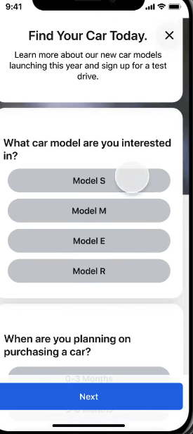
Lead forms are fantastic for getting a campaign off the ground quickly and feeding Facebook’s algorithm with conversion data. For beginners, they are the fastest way to get started.

Landing Pages: Scaling
A landing page is a dedicated page on your own website built for a single purpose: converting a visitor into a lead. The user clicks your ad and is taken off Facebook to your branded environment.
Pros | Cons
✅ Higher Quality, Higher Intent Leads | ❌ Harder to Set Up
✅ Builds Your Brand & Authority | ❌ More Complicated Funnel
✅ Total Control Over the User Experience | ❌ Higher Initial Cost Per Lead
For this bootcamp, we will focus on making Facebook Lead Forms work for you. They are the perfect starting point. But it’s critical you understand that a custom landing page is the next step in your evolution as an advertiser. → [Link to apply for our DFY service]
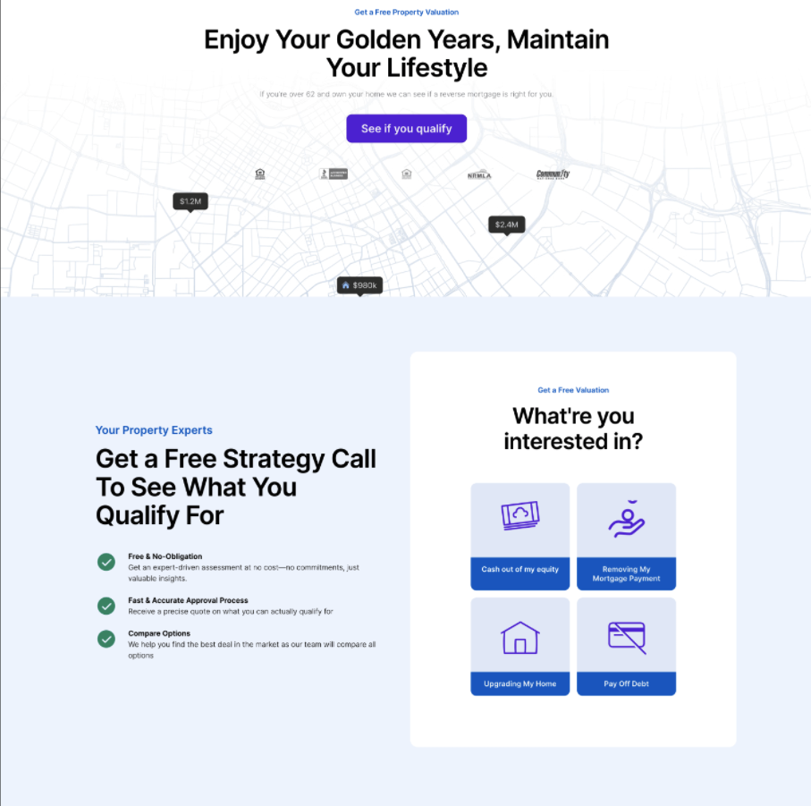

Lead Nurture Best Practices

Introduction

In this video, we're going to break down everything I’ve learned over the years on nurturing leads, giving you the exact frameworks and best practices to maximize your response rates, show rates, and ultimately, your close rate.

Nurture Fundamentals

The second a lead puts in their information to learn more about your offer, a clock starts ticking due to something we call lead decay. This means that as time goes on, the interest level of the prospect is gradually decreasing.
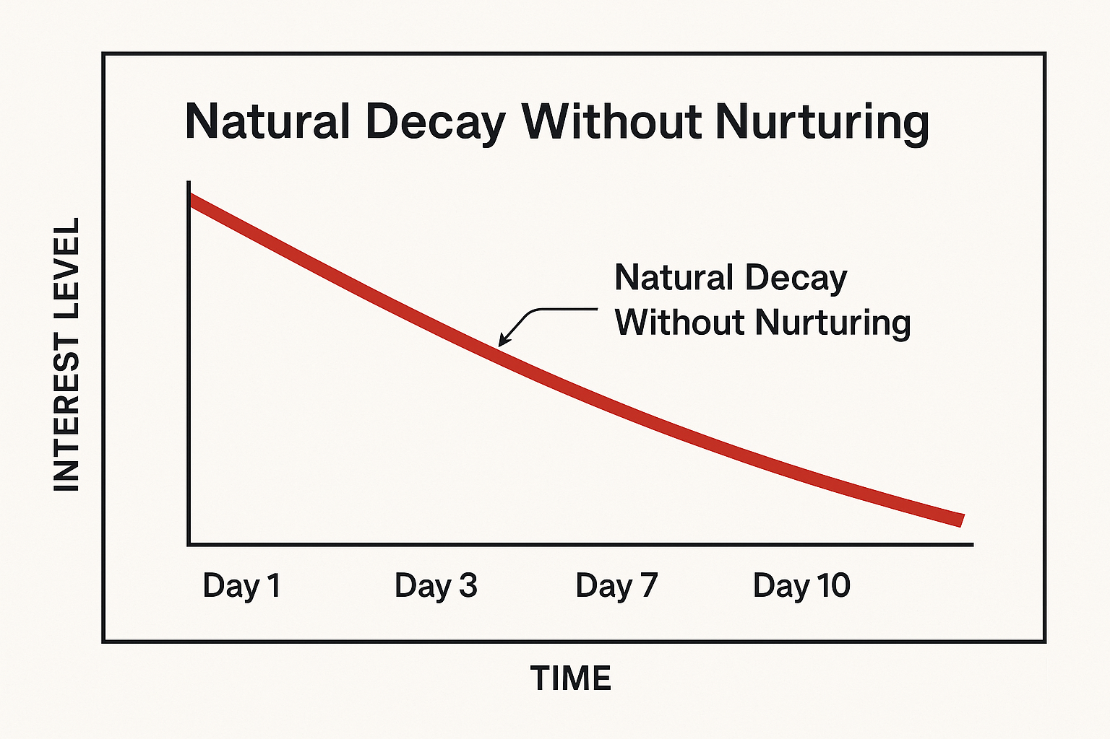
You’ve probably heard of the term speed to lead before, and this is exactly WHY it’s so important. There is a direct correlation between how fast you contact your leads / how persistently you follow up, and the likelihood of them booking a sales call, showing, and closing.

Most of your lead-to-booking / show rate problems come from one simple failure: you are not
acting fast enough. The amount of people in here who have complained to me about only 50% of their leads booking a call or showing up, then when we go into their CRM and check the absolute basics of calling their leads within 5 minutes it's not being done.

If you do not call your leads within 5 minutes, you deserve to make no money - you already know this but so few of you actually do it right. You’ll focus on it so much with your clients, but forget to do it for yourself.
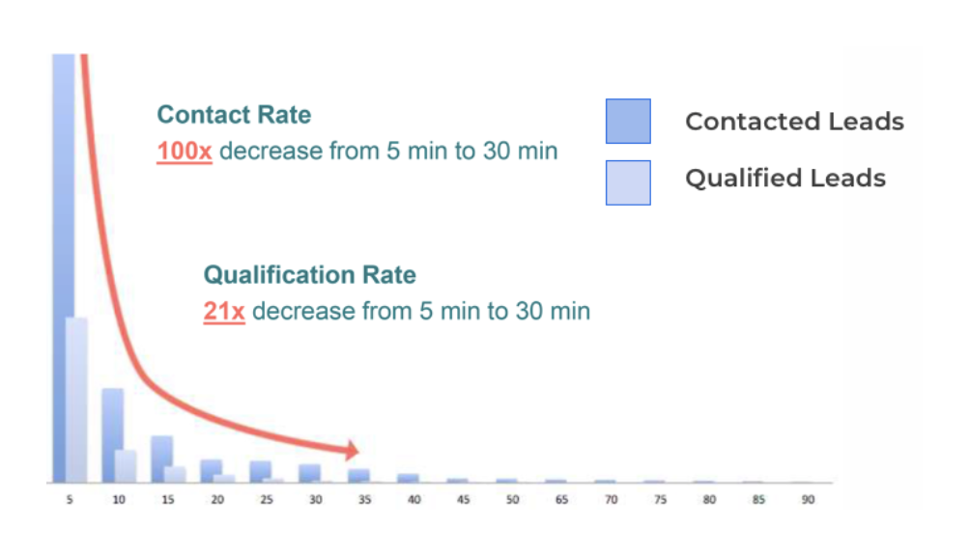
I don't just mean “thinking” your speed to lead is dialled in, I mean actually tracking it with every single lead that comes in.

Now in order to combat lead decay, you first need to understand the different Levels Of Interest. Every lead exists in one of three states:
- Curious: They’re just exploring. They saw an ad and was interested in what you have to offer
- Interested: They’re leaning in. They understand they have a problem and are actively considering solutions.
- Convicted: They’re hot. They need a solution now and are ready to take action.
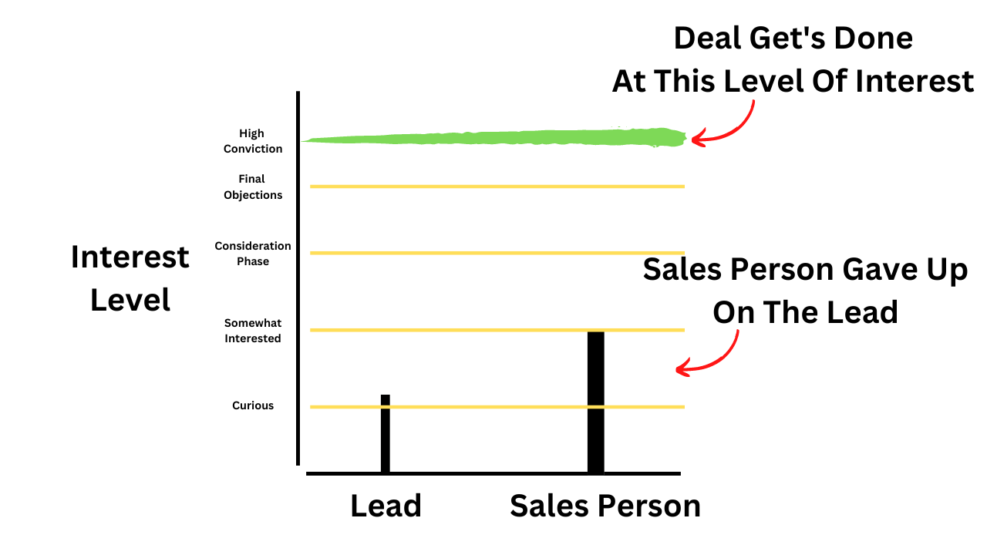
Your entire nurture process, both automated and manual, has one single goal: to move leads as close to the convicted side of the spectrum as humanly possible. When you do this, you wont just close the leads who come in and are ready to buy (which is a select few), you’ll be able to push curious leads into potential buyers too.

Understanding this and implementing every best practice I break down below will allow you to make a shit ton more money out of your existing ad budget and squeeze the lemon out of every dollar you spend on ads.

#1 Speed To Lead

As we saw with the lead decay graph, you have to be fast. This is non-negotiable.
- Automated: Your first automated text/email must go out instantly.
- Manual: Your setter must be dialing booked calls the minute they book or opt-in
  - I get some kickback from other agencies on the lead booking and not wanting to annoy them the minute they book - if you’re pissing a high % of people off, that means these calls aren’t being done right

For most founders you’ll be strapped on time in order to execute this at the level it needs, in which case you should consider getting a setter. The amount of people who don’t think they’re ready to get a setter, then I push them to get one and they make a shit ton more money is unreal.

A setter is an INVESTMENT, if they just help you close one more deal that you otherwise wouldn’t have by relentlessly calling / following up with leads, you already make an ROI (Sam story…)

#2 Value Based Messaging

Why This Matters 🧠
Here's the truth most LOs don't want to hear:
The way you message your leads is costing you deals.
Not your product. Not your rate. Not the market. Your messaging.
Most LOs reach out to a new lead and immediately ask for something — a call, a booking, a commitment. The lead barely knows who you are, and you're already asking them to give you their time.
That's not nurturing. That's chasing.
The shift is simple: stop leading with what you want, and start leading with genuine intent. Show the prospect that you actually read what they told you, that you understand their situation, and that you're reaching out because you want to help — not because you have a quota to fill.
When you do this, something changes. The lead goes from feeling like a number in your pipeline to feeling like someone you actually care about. And that feeling is what gets them to show up to your call, trust you when they get there, and ultimately move forward with you.

The Core Idea 🔄
Every message you send should make the prospect feel seen, not sold to.
That's it. That's the whole framework.
The way you do that is by referencing their situation — their words, their concerns, their goals — in every single touchpoint. Not a generic "just checking in." Not a copy-paste template. A message that could only have been sent to them.
This is what separates a 40% show rate from a 70% show rate. Not a fancy funnel. Not a new ad. Just messaging that feels human and intentional.

The Wrong Way vs. The Right Way ⚖️

⛔️ The Wrong Way
A lead fills out your form. You send:
"Hey John! Thanks for your interest in learning more about reverse mortgages. Click here to book your call: [LINK]"
This message is about you. It's asking John to do something for your benefit. John doesn't feel like you know him at all — because you don't. You haven't even acknowledged what he told you on the form.

✅ The Right Way
Same lead. Same form. But this time, you actually read what John wrote.
John said his biggest concern is that he's worried about running out of money in retirement.
So you send:
"Hey John — I saw you mentioned being worried about outliving your savings. That's honestly one of the most common things I hear, and it's exactly why I wanted to reach out personally. I think our conversation is going to be really valuable for you. Looking forward to connecting."
That's it. No link. No pitch. No ask.
Just a message that shows John you were paying attention. He feels seen. He feels like this call might actually be worth his time.

CRM vs. Spreadsheets: The Scalability Question 📈
So, the leads are coming in. Where do they go? For many beginners, the answer is a Google Sheet. And for the first 10-20 leads, that might work. But it’s a system built to fail.
Manually tracking leads in a spreadsheet is the definition of leaving money on the table. You can’t respond in under 5 minutes. You can’t track dozens of conversations. You can’t build a scalable, repeatable process.

The Power of a CRM
A CRM is your central command center for all leads. It’s the brain of your Lead Engine. When a lead comes in, a CRM can instantly:
- Trigger Automated Follow-up: Send an immediate text message and email to the new lead, ensuring you hit that critical 5-minute window every single time.
- Organize Your Pipeline: Visually track where every lead is in the sales process, from “New Lead” to “Appointment Booked.”
- Automate Nurturing: Send a series of pre-written messages over days or weeks to stay top-of-mind.
- Save You Hours of Manual Work: No more copy-pasting, no more manual reminders. The system does the heavy lifting.
Key Takeaway: A spreadsheet is a list. A CRM is a system. To build a real business, you need a system. There is no reason to be manually managing the initial phases of lead follow-up in today’s world. This is how you optimize your contact rate and ensure no lead is left behind.

